Ageing Well Action Plan 2022 - 2026
Stakeholder pack

The purpose of this document is to outline key communication resources and information available for you to support the launch of Ageing well in Victoria: An action plan for strengthening wellbeing for senior Victorians 2022-2026

Background
Ageing well in Victoria: An action plan for strengthening wellbeing for senior Victorians 2022-2026 outlines the Victorian government’s commitment to support Victorians to age well and enjoy the benefits of living longer, as respected members of our community.
The actions within the plan are informed by the lived experience of older Victorians. Almost 5000 older Victorians participated in a 2019 survey by the Commissioner for Senior Victorians which informed the 2020 report, Ageing well in a changing world, and over 1000 older people participated in in-person consultations with the Commissioner in 2021.
The plan will drive action across four key areas:
- Resilient connected seniors: We will support older people to have a sense of purpose through social, cultural, and intergenerational connections
- Tech savvy seniors: We will support older Victorians to take part in the digital world, and ensure those who can’t do not experience discrimination and can access services via other means
- Valuing senior Victorians: We will reduce ageism and increase visibility and appreciation of older people as valued and contributing Victorian citizens
- Health self-care: We will use healthcare advances driven by the pandemic to improve the health of older people and their ability to protect themselves.
The actions within the plan will be undertaken in partnership with community organisations, peak bodies, local government and government services.

Website links
- http://www.seniorsonline.vic.gov.au/ageing-well-action-plan

Key messages
- The Minister for Disability, Ageing and Carers Colin Brooks launched ‘Ageing well in Victoria: An action plan for strengthening wellbeing for senior Victorians 2022-2026'.
- The action plan outlines the Victorian Government’s vision to support older people to age well by continuing to participate in their community, and safely ageing in-place at home, in the community or aged care.
- More than one in five Victorians are aged 60 and over. Victoria’s older population is growing faster than any other age group and is set to increase by 60 per cent by 2046.
- The plan is informed by the lived experience and expertise of older Victorians, including almost 5000 participants in a 2019 survey by the Commissioner for Senior Victorians for the 2020 report, Ageing well in a changing world, and over 1000 older people who participated in in-person consultations with the Commissioner in 2021.
- The Office for Senior Victorians, the Commissioner for Senior Victorians and members of the Senior Victorians Advisory Group worked tirelessly to develop the action plan.
- The actions within the plan will be undertaken in partnership with community organisations, peak bodies, local government and government services.
- To read the plan visit the Seniors Online website <www.seniorsonline.vic.gov.au/ageing-well-action-plan>.
- If you have any questions about the plan, or ideas about how we can promote the plan, please email the Office for Senior Victorians at seniorsprojects@dffh.vic.gov.au.

Social media posts
Platform | Copy | Image
Facebook/LinkedIn | 📣 Launched today: The Victorian Ageing Well Action Plan 2022-2026 outlines how the Victorian government will ensure older Victorians are appreciated, respected and supported to age well.  Read the plan on the Seniors Online website <www.seniorsonline.vic.gov.au/ageing-well-action-plan>. | 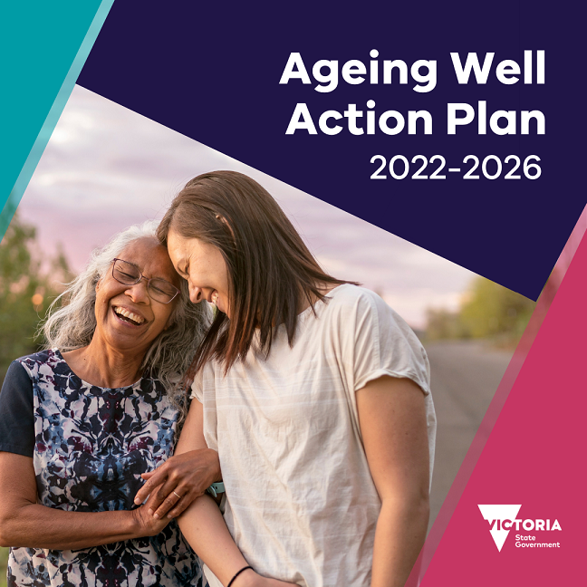
Twitter | The Victorian Ageing Well Action Plan 2022-2026 outlines how the Victorian government will ensure older #Victorians are appreciated, respected and supported to age well. More: https://bit.ly/3O5yhLd
Instagram | 📣 Launched today: The Victorian Ageing Well Action Plan 2022-2026 outlines how the Victorian government will ensure older Victorians are appreciated, respected and supported to age well.

Newsletter article
New action plan released to support Victorians to age well
The Minister for Disability, Ageing and Carers Colin Brooks launched ‘Ageing well in Victoria: An action plan for strengthening wellbeing for senior Victorians 2022-2026' today.
The state’s four-year action plan will support Victorians from all backgrounds to connect socially and to live healthy, active, and purposeful lives. More than one in five Victorians are aged 60 and over. Victoria’s older population is growing faster than any other age group and is set to increase by 60 per cent by 2046.
The action plan outlines the Victorian Government’s vision to support older people to age well by continuing to participate in their community, and safely ageing in-place at home, in the community or aged care.
The plan is informed by the lived experience and expertise of older Victorians, including almost 5000 participants in a 2019 survey by the Commissioner for Senior Victorians for the 2020 report, Ageing well in a changing world, and over 1000 older people who participated in in-person consultations with the Commissioner in 2021. The Commissioner for Senior Victorians and members of the Senior Victorians Advisory Group have been actively involved in the development of the plan.
The whole-of-government action plan will drive action across four priority areas:
- Resilient connected seniors: Supporting older people to have a sense of purpose through social, cultural, and intergenerational connections
- Tech savvy seniors: Supporting older Victorians to take part in the digital world, and ensure those who can’t do not experience discrimination and can access services via other means
- Valuing senior Victorians: Reducing ageism and increasing visibility and appreciation of older people as valued and contributing Victorian citizens
- Health self-care: Using healthcare advances driven by the pandemic to improve the health of older people and their ability to protect themselves.
The actions within the plan will be undertaken in partnership with community organisations, peak bodies, local government and government services.
Read the plan on the Seniors Online website <www.seniorsonline.vic.gov.au/ageing-well-action-plan>.

To receive this document in another format, email the Office for Senior Victorians <seniorsprojects@dffh.vic.gov.au>
Authorised and published by the Victorian Government, 1 Treasury Place, Melbourne.
© State of Victoria, Australia, Department of Families, Fairness and Housing, June 2022.

